ANNOUNCEMENTS:
Outreach: ‘Buckets of Hope’ is St. John’s monthly outreach for
SafeHaven Domestic Abuse Center. Our donations supply each family with the necessary supplies when they leave the shelter. Check the list in the Parish Hall to see what is needed. Please continue to bring non-perishable items for SAFPARC (Shawano Area Food Pantry). Items can be placed in the back of the church.

PICK UP IN THE RACK IN THE HALL:
- flyers that tell you about St. John's
- copies of sermons
- copy of the Church and Diocese electronic newsletter
- tracts that help with life's issues

UPCOMING DIOCESAN EVENTS:
6/29: Eucharistic Festival, St. Paul's Cathedral Fond du Lac, 11 AM

St. John's Upcoming Special Events:
July 22-25: Vacation Bible School from 9-12 daily. See Meghan Keberlein for details and to volunteer to help out. Volunteers needed for snacks, crafts, music, games, teaching.
Sundays in July and August: Coffee hour mini-classes on the Lives of the Saints
September 8: 9:30 AM Outdoor mass, parish picnic and pony rides for children
September 8: 1:30 PM: Blessing of the Animals

The Fourth Sunday After Pentecost
June 16, 2013
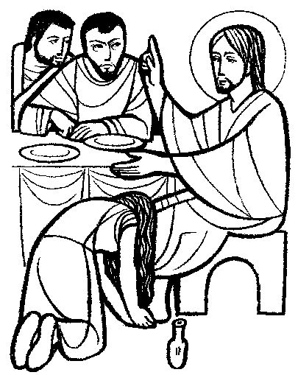
“Your faith has saved you, go in peace”
St. John’s Episcopal Church
141 South Smalley St., Shawano, WI
http://www.shawanoepiscopal.org
The Rt. Rev. Russell Jacobus, Bishop
The Rev. Mary S. Trainor, Vicar
Church Phone 715-526-3686
Vicar’s Phone 715-252-4816
pastormaryt@gmail.com

St. John’s Episcopal Church, Morning Prayer, Rite II

(please stand) Processional Hymn ………………………….#691
“My Faith Looks Up To Thee”
Deacon: Grace to you and peace from God our Father and the Lord Jesus Christ.
(please kneel if you are able)
Deacon: Let us humbly confess our sins unto Almighty God.
Confession of Sin (all together)………………….…BCP page 79
Deacon: Lord open our lips.
All: And our mouth shall proclaim your praise. Glory to the
Father, and to the Son, and to the Holy Spirit, as it was in the beginning, is now, and will be forever. Amen
Venite, p. 82 Deacon: The Spirit of the Lord renews the face of
the Earth:
(please sit)All: Psalm 5:1-8.............................……….bulletin insert
Gloria Patri, p. 84
Lay reader: Old Testament Lesson…………………. .bulletin insert
(please stand) All: Canticle 16: A Song to the Lamb……page 93 (please sit)
Lay reader: Epistle Reading……..………..bulletin insert
(please stand)ALL: Canticle 19:The Song of Zechariah...page 92 Deacon: Gospel reading: Luke >>>>>>>>>….............bulletin insert
Sermon………………………………….…Deacon Bruce McCallum
The Peace
Offering Hymn: “Before Thy Throne O God We Kneel….. # 574
The Prayers
The Lords Prayer, page 97
Suffrage B, page 98
Collect of the Day (Insert)
Prayers of the People: Form VI …………………….p. 392
Those in need of our prayers: For healing: Marlene, Elora, Mike, George, Bernie, Dan, Adeline, Bruce, Pam, Julie, Frances, Laura, Dave, Gary, Clark, Gerald, Nora, Emma, Brian, Kathleen, Ann, Wendy, Deacon Bruce; for Keith serving in Afghanistan, Aaron, Ken and all those deployed, Diocesan Cycle of Prayer:All Saints chapel, Elkhart Lake.

Prayer for Fathers Day: Father, it is Your commandment that we should honor our fathers: Hear the prayers we offer You for our fathers, alive or in heaven, today. We give thanks for our fathers, for the sacrifices they made for us and their love of us. We give thanks for all the fathers in the world, and pray that they be good role models and loving to their children. When their hearts break because they can’t do it all, please help them turn to you for strength and patience. Thank you, Father God, for being our heavenly father who loves us so. May your blessings be with all fathers today. In Jesus Name. Amen
Prayer for election of a new Bishop, page 818
St. Francis, page 833
Prayer of St. Chrysostom, page 59
Closing Hymn “Theres A Wideness in God’s Mercy”………...#470
Announcements, Dismissal

TODAY at St. John's
Everyone is invited into the Hall for coffee during Fellowship time. This Fathers Day, Deacon Bruce will have a short lesson about Abraham, the father of the worlds three great religions. Thank you to Deacon Bruce McCallum for serving as Officiant and Preacher today.
Announcements
Please sign up on the clipboard in the Hall for the various roles and tasks of the church. There are many ways to serve.

You can make a difference in helping out those less fortunate in Shawano. How? You can bring non-perishable (canned or dried goods) foods to church and place them in the basket near the Church entrance; food is delivered weekly to the Shawano Food Pantry (check dates on food please). You can also bring cleaning supplies and toiletry items for those staying at the Shawano Domestic Abuse Shelter; please place these items in marked bins.

